**VCS Task**

Q1: Establish a new directory :-

Ans : Am using the putty by login the Linux centos and am creating the directory got the git and named called Guvitask

Step1 : am creating the main Dir by using the cmd called mkdir Guvi this is the mail directory for the git

Step 2: am creating the repo file for the git name called Guvitask you can see the cmd below

Mkdir guvitask

To make this as the git repo need to use git init

Screen short pasted below

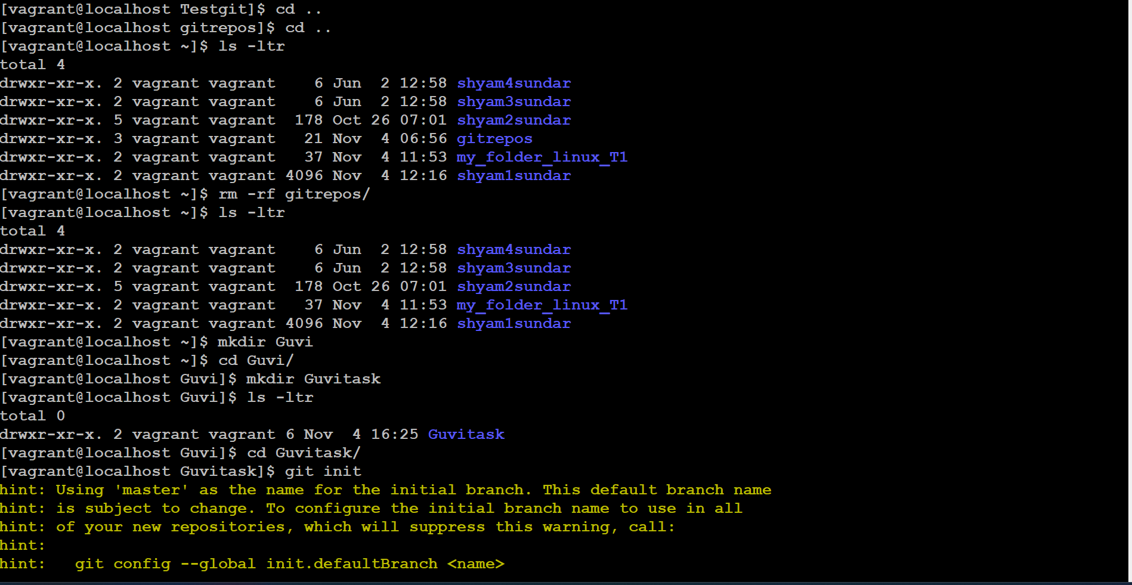

Am using ls -a to check the git file was generated

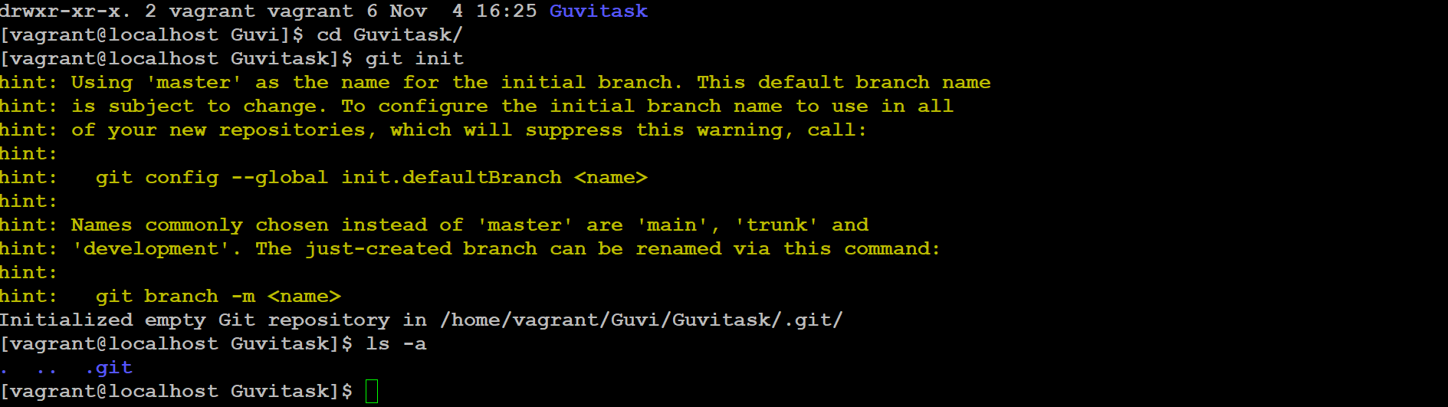

* Yes its .git was generated now

Now this repo was in the master branch if we need to change the name of the master we need to use Git branch -m main this commend will helps to rename the current branch

Before that I need to create some files in this Git buy using mkdir and touch

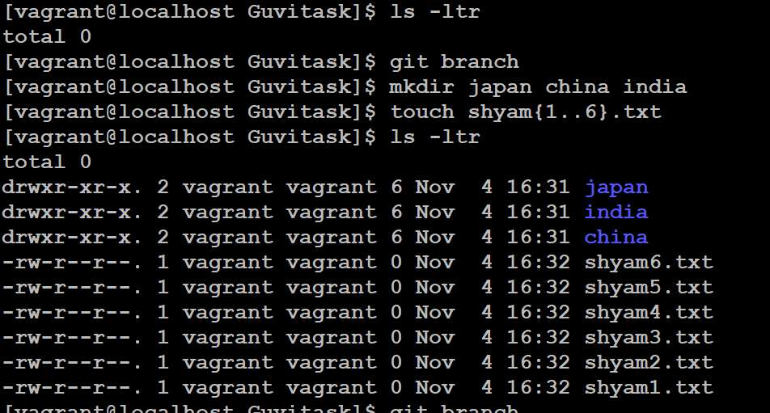

* I have created the file you can see in the screen short and in that each file I added the some text and in the director I created the some text file as well

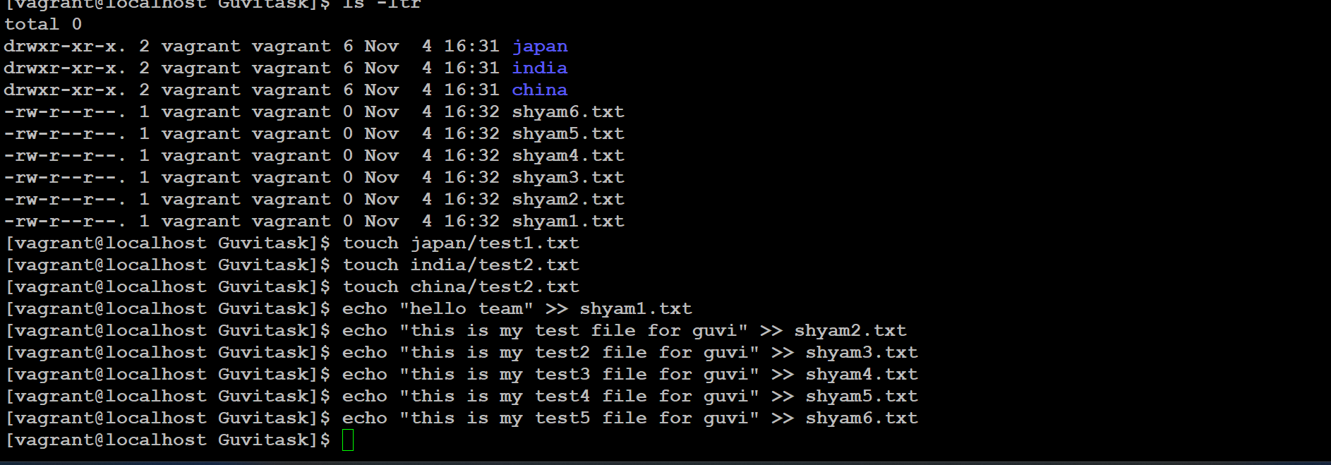

* Now we need to check the status before adding to mail by using the commend git status 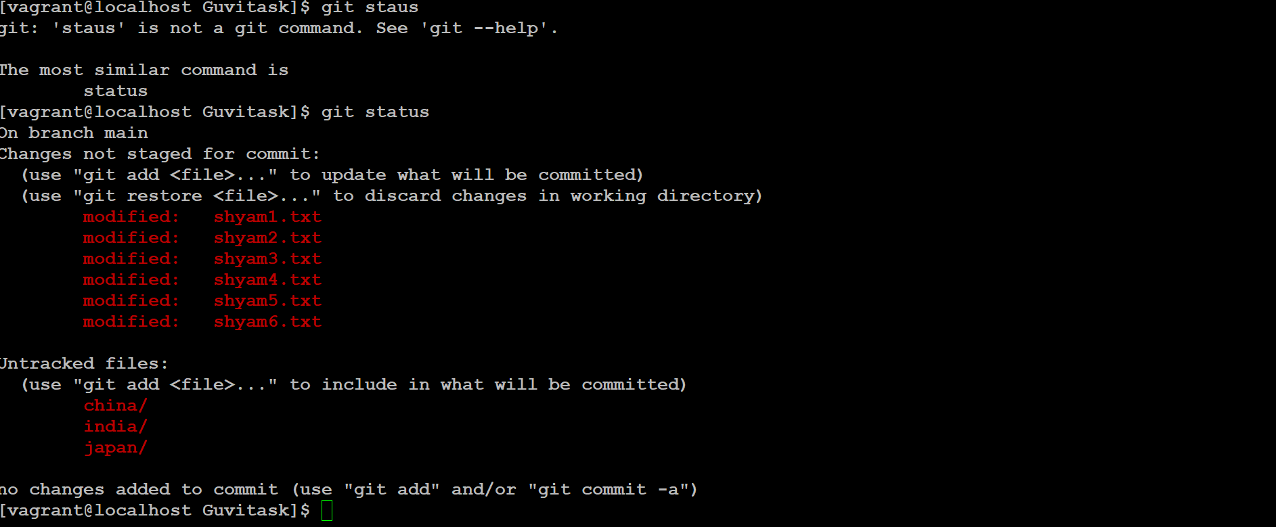
* Now am planning to remove Japan director from that list by using the cmd line called git reset
* Before that am using the git add . to update the file to repo folder after that am ignoring the Japan file

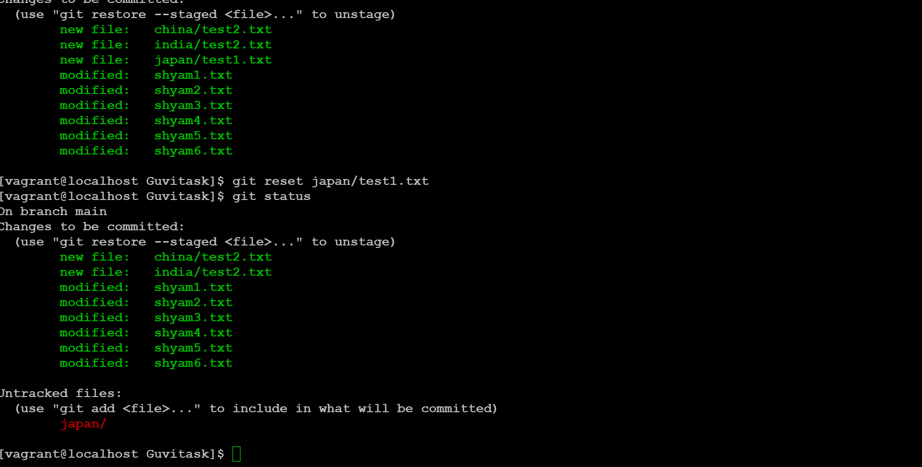

* Now am using the commit cmd line to comit all the file to main repo by using the cmd line git commit -m “new text file was add to all folder”
* Now after commit the file and using the git status to check except Japan folder all file was updated to main
* 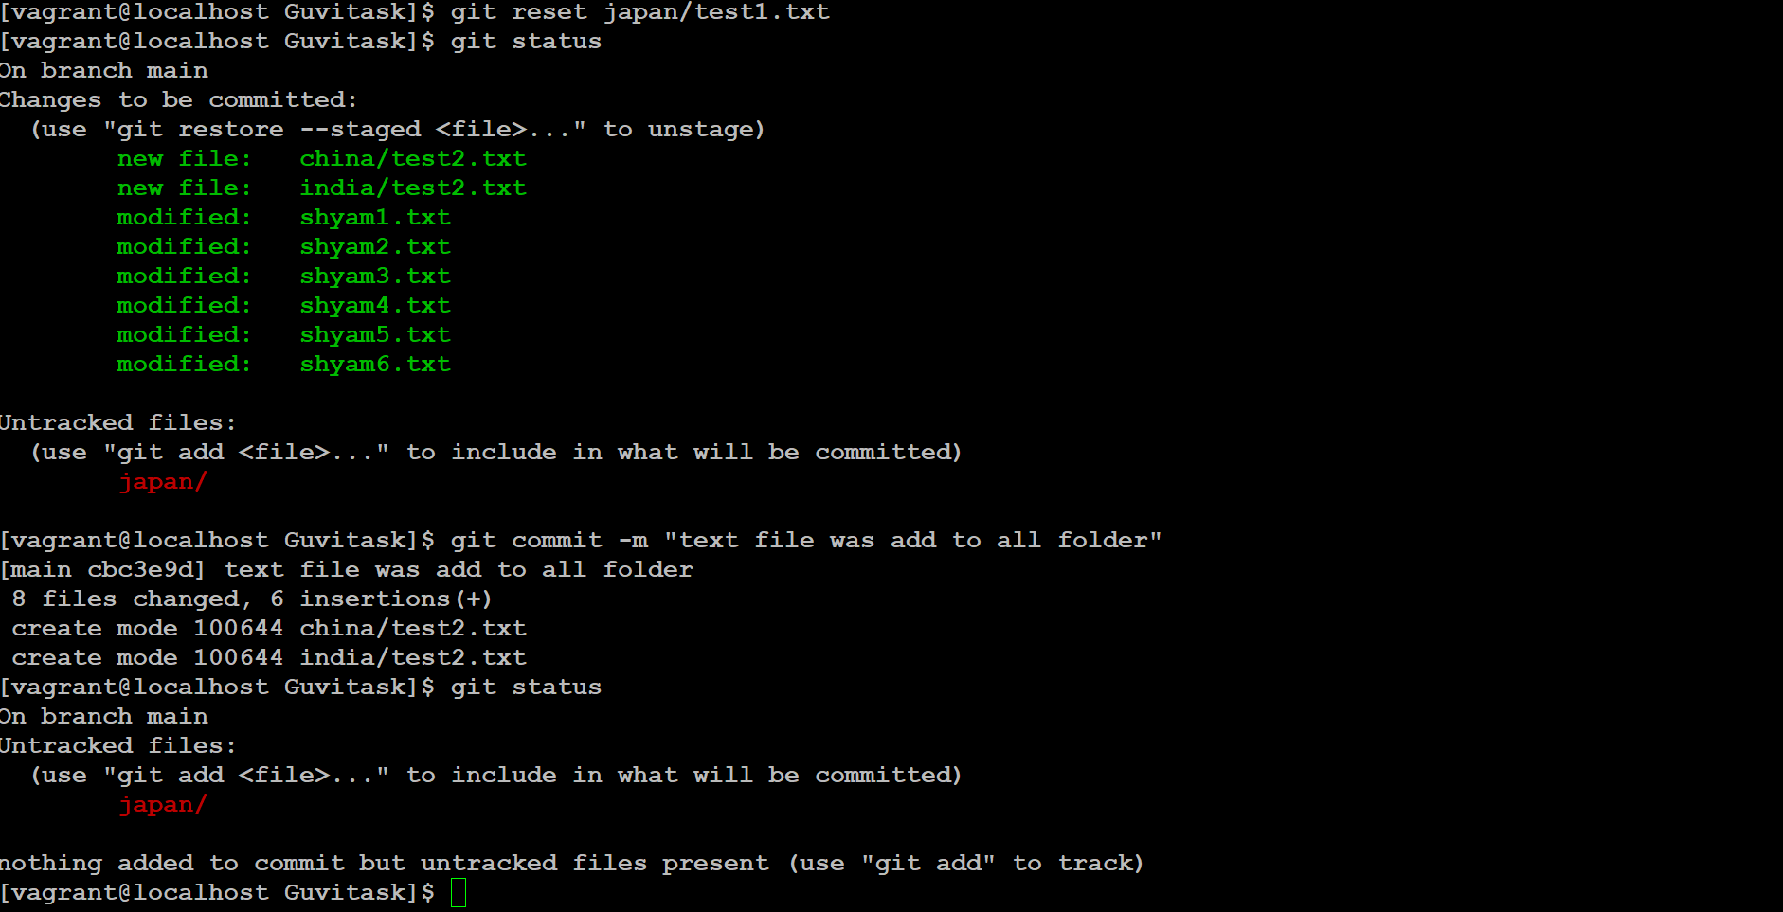
* Now again am updating the Japan to the mail by using git add . , and using the git commit to the main branch

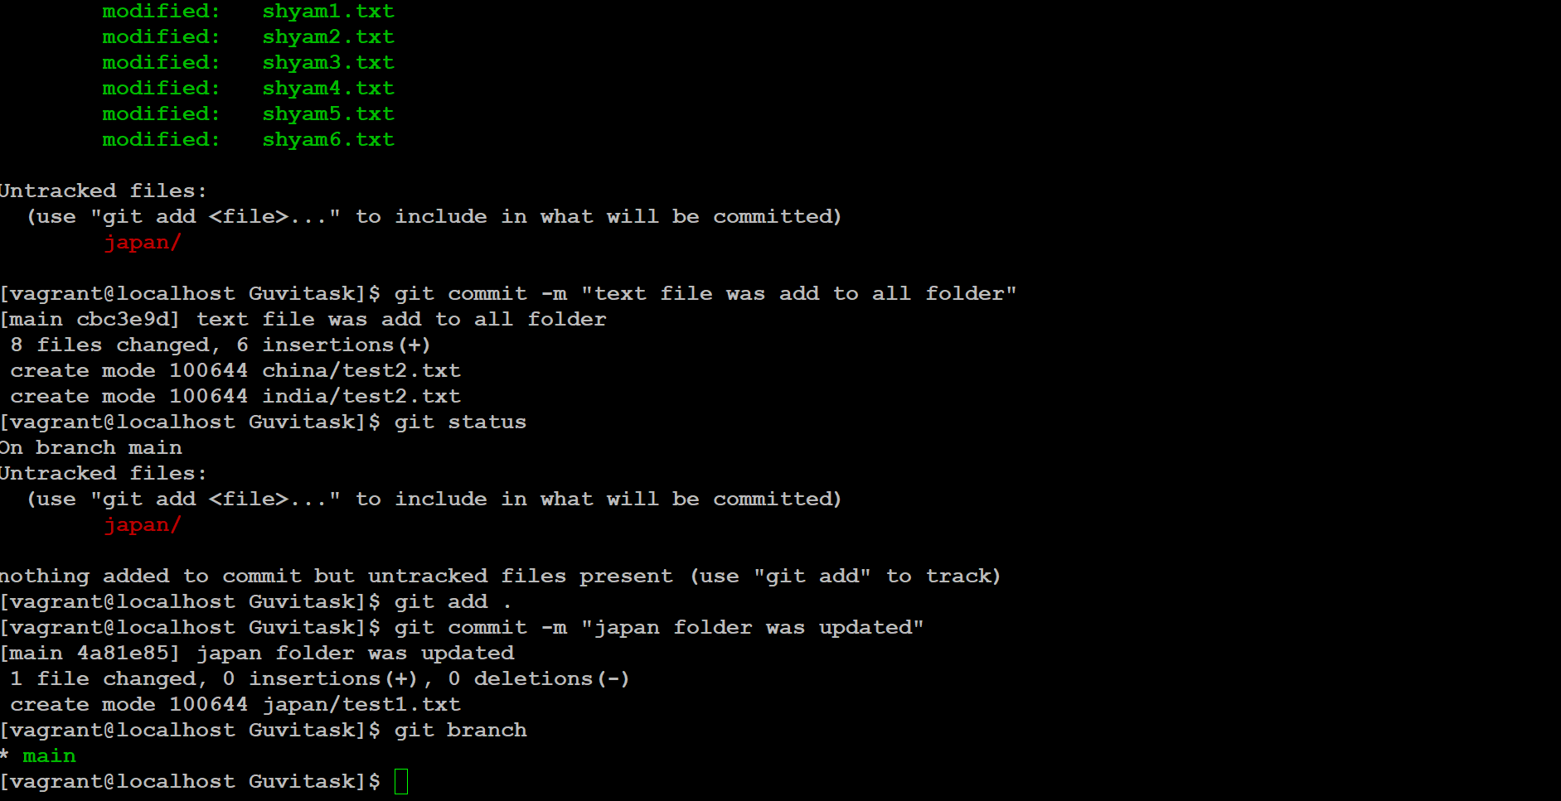

* Now am opeaning my git webpage and creating the same file name called Guvitask repo and adding these document in the cml line

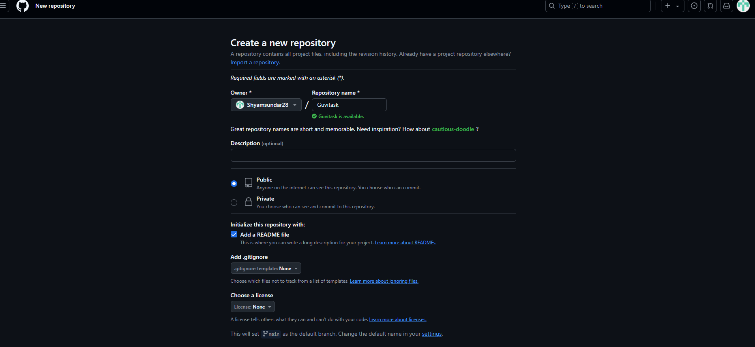

Click create

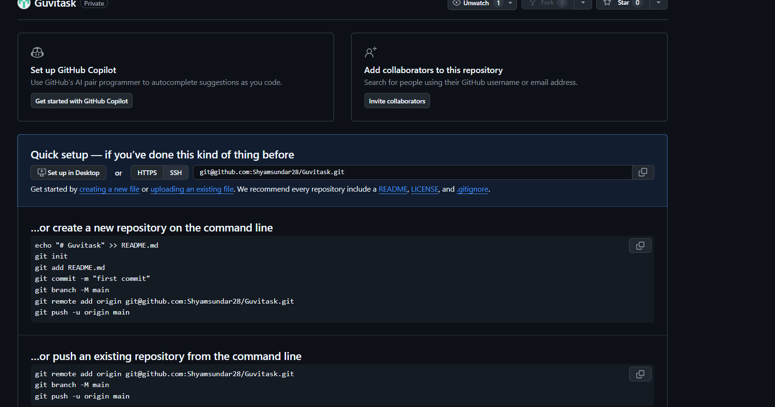

* Am using the push an existing repo cmd ling given below

git remote add origin git@github.com:Shyamsundar28/Guvitask.git

git branch -M main

git push -u origin main

* All content was added successfully in the mail git

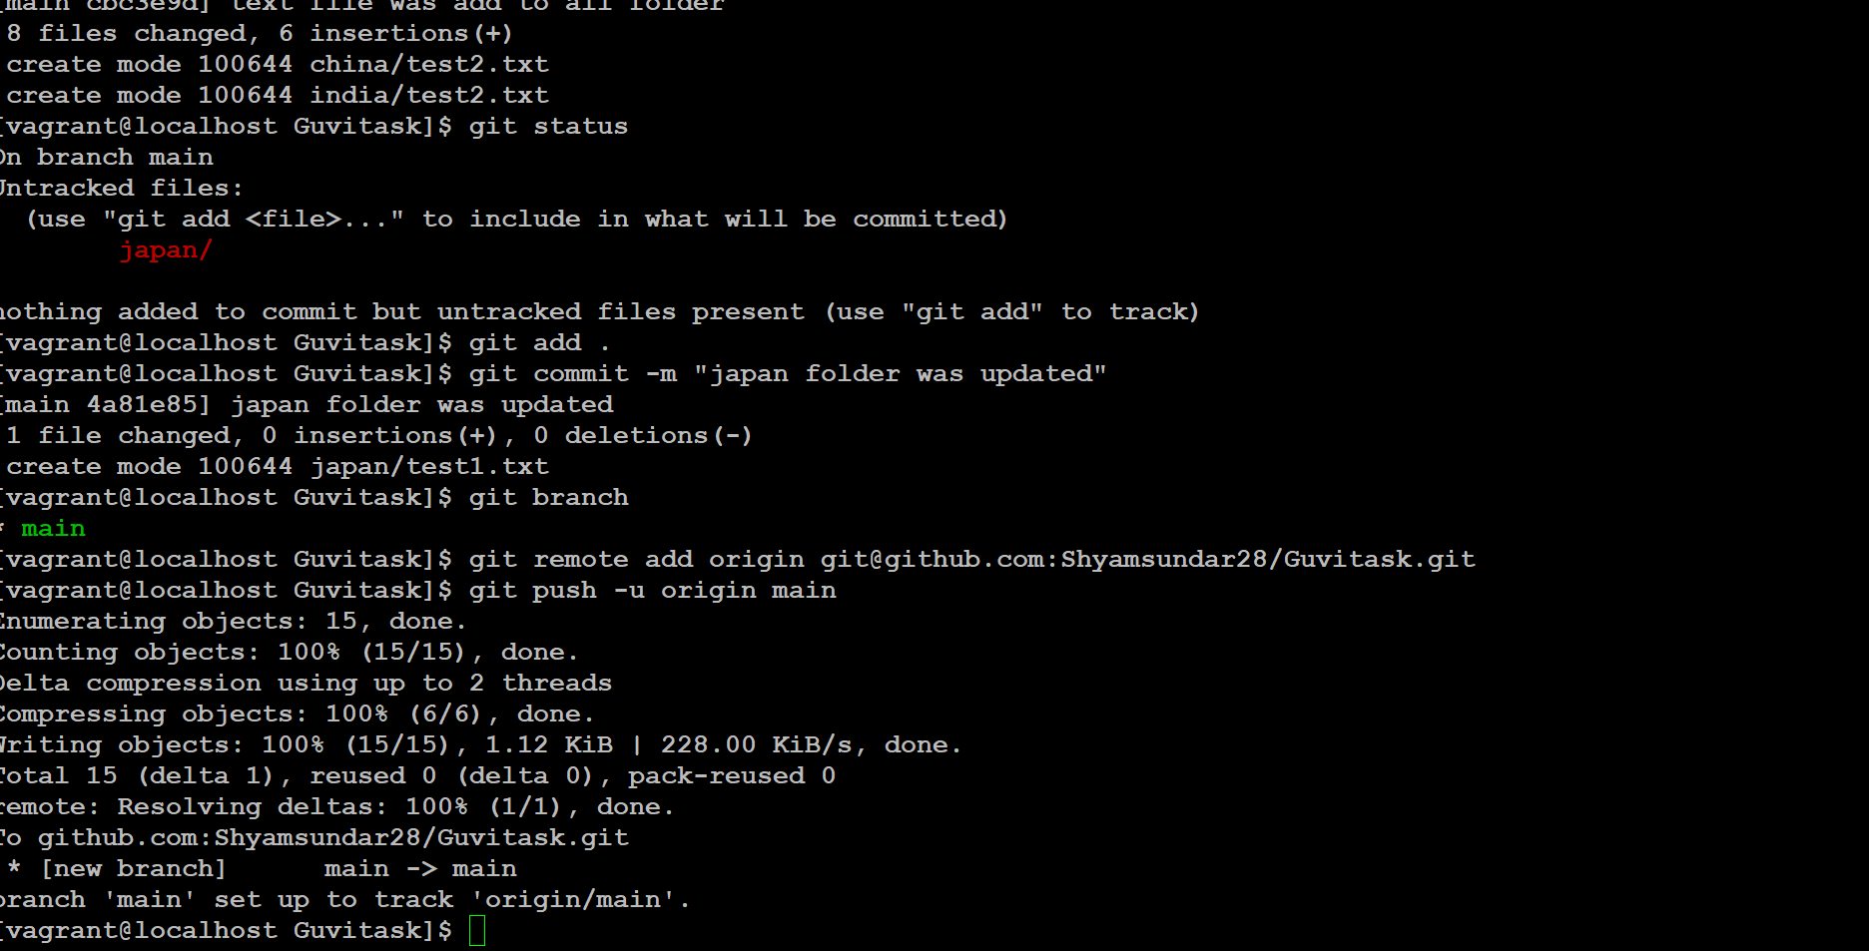

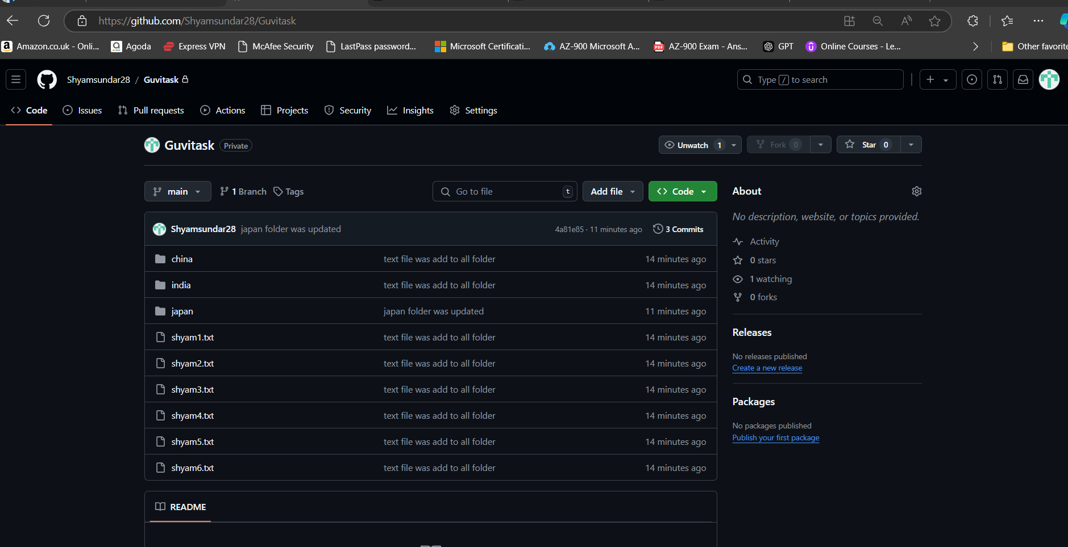

Now am planning to create the new branch and execute some files in that 2nd branch

Git branch testingfolder

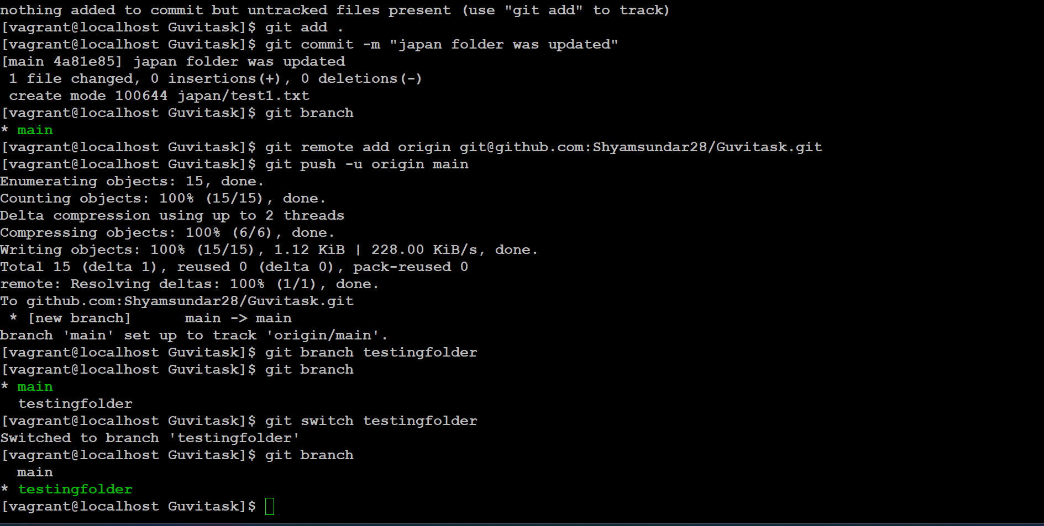

Now am trying to create the some files in the testingfolder director and txt file

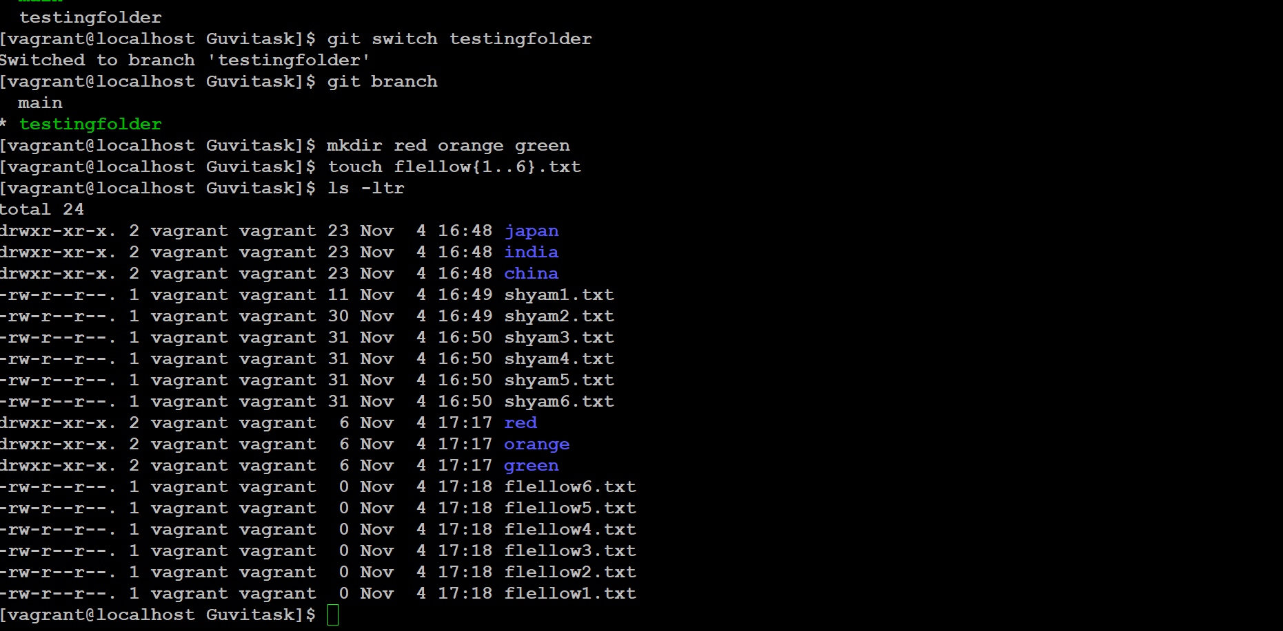

* Now am adding some content in all txt file and giving the commit cmd to update in to the testingfolder

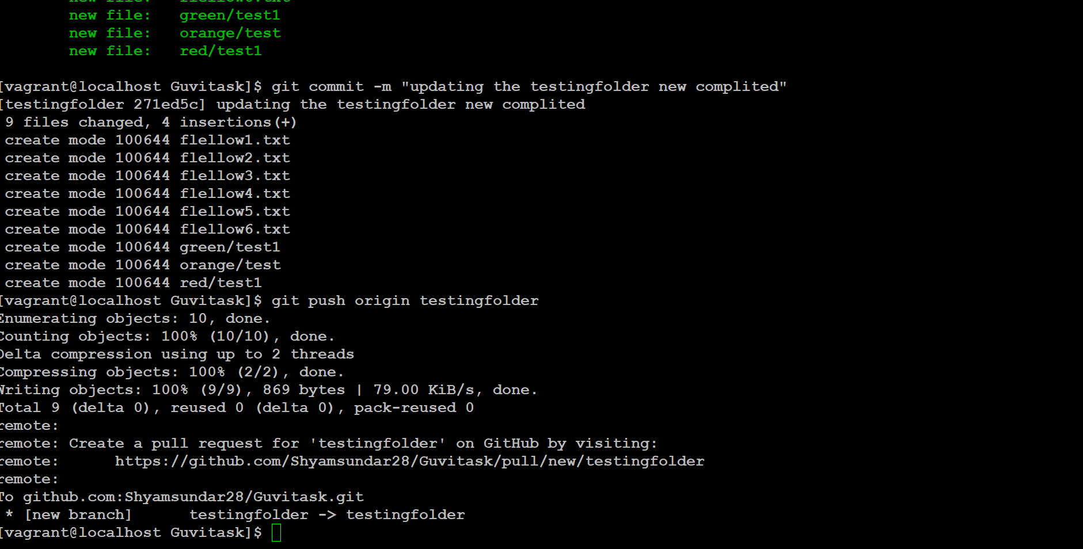

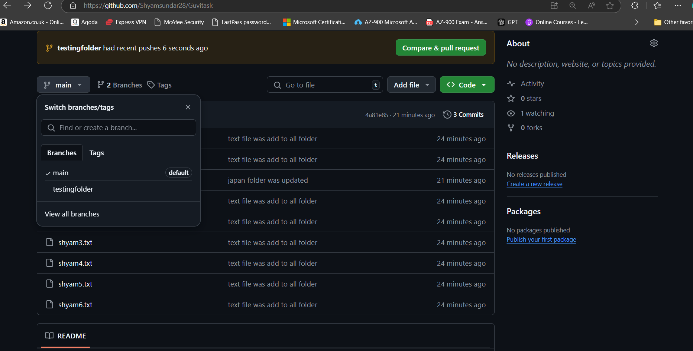

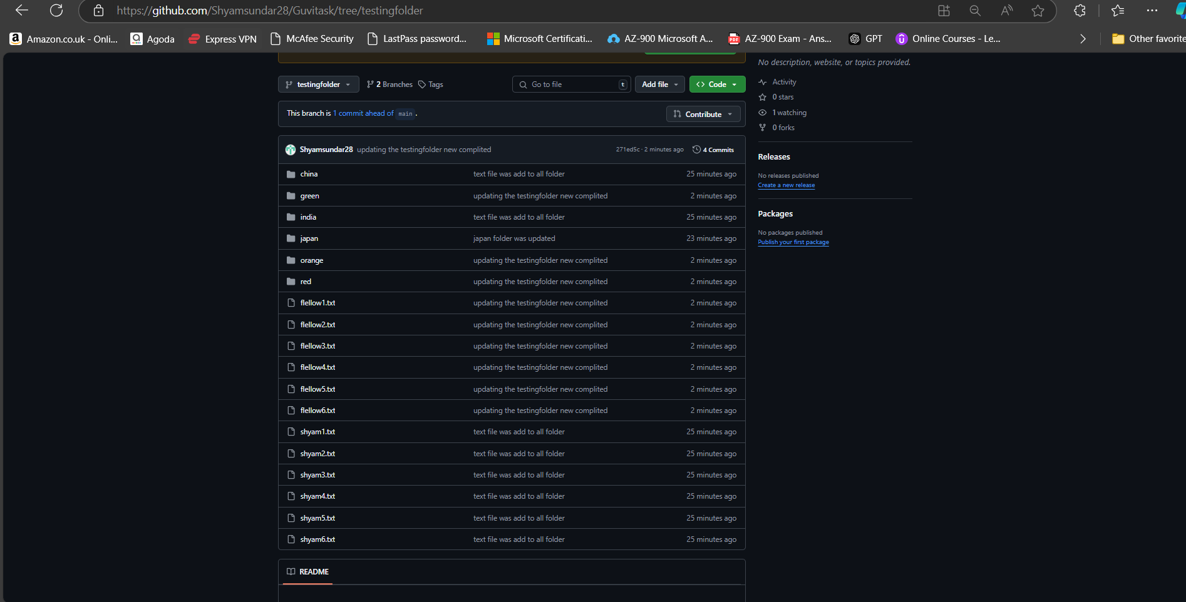

To create the ssh ke we need to use ssh-keygen in the below screen short I have already created the ssh key I overtried the key again

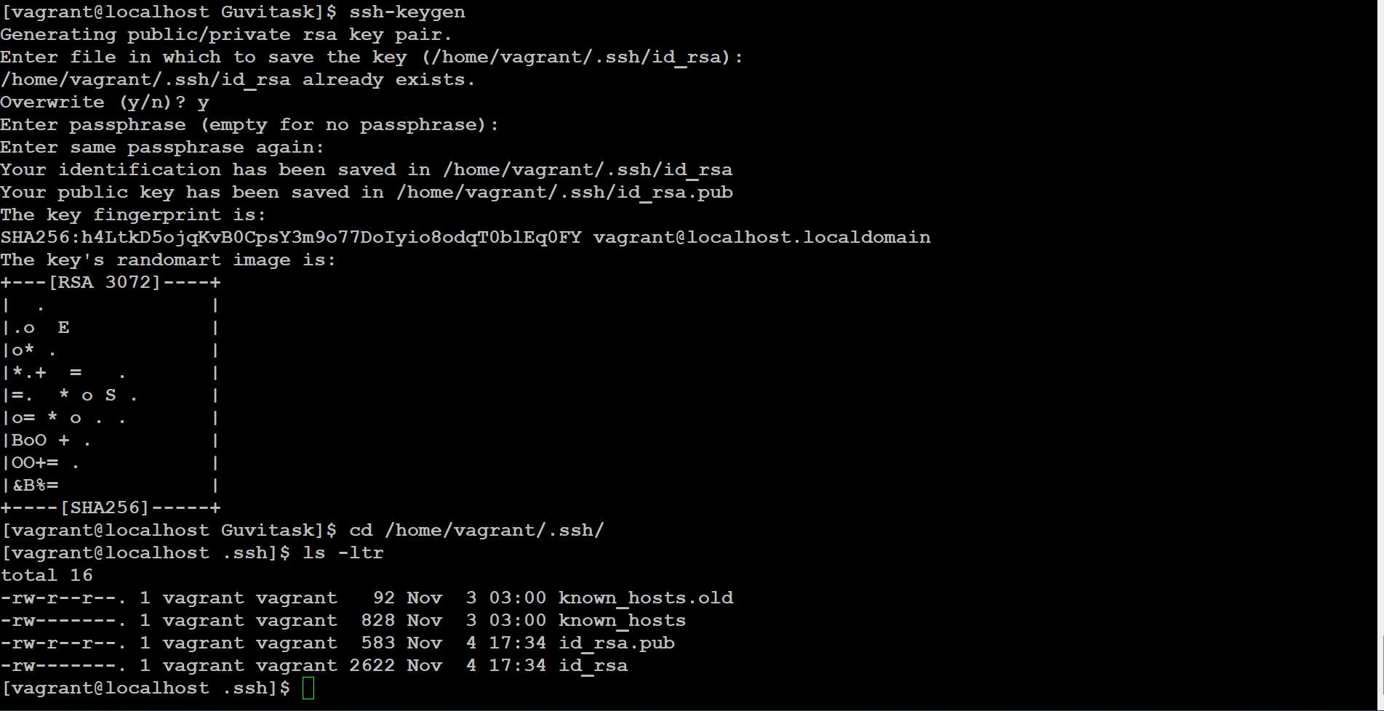

So if we need to provide the sub branch we can give that ssh key for secure perpose

Git clone ssh url